TSDS L2 Validations

L2 Validations are business rule validations that are executed in the DMC on data that is destined for TSDS. Level 2 Fatal, Special Warning, or Warning errors do not prevent the data from being promoted to TSDS. Scheduling and viewing L2 validations are optional but is highly recommended. This step will allow LEAs to begin reviewing and correcting errors earlier in the submission process.

- Log into TEAL.
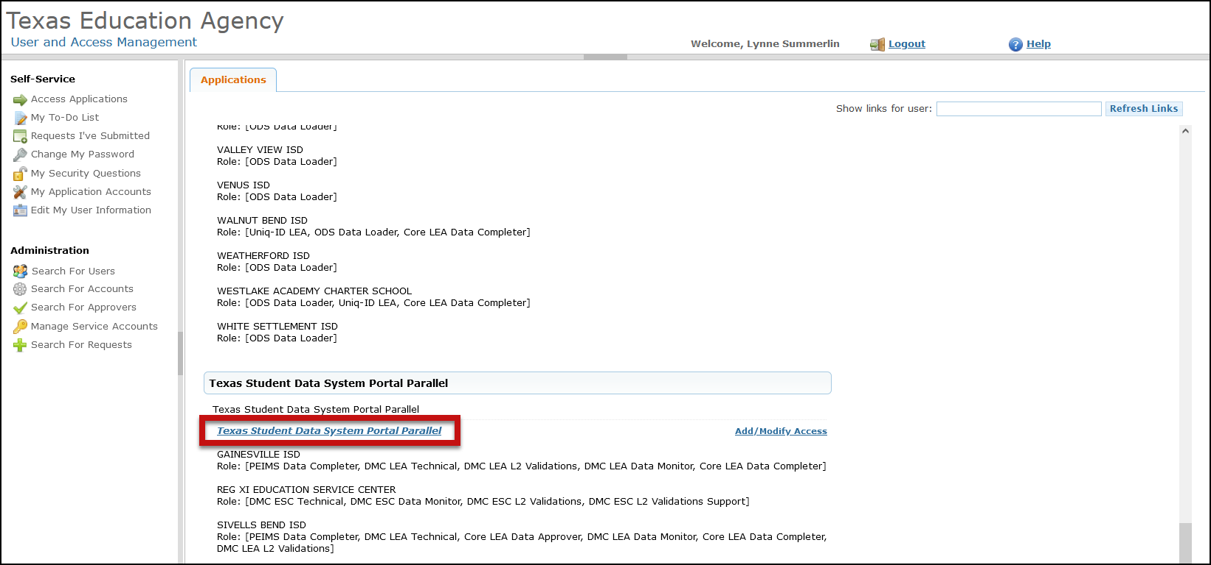
- Click on Texas Student Data System Portal Parallel link.

- Click on Manage IODS.

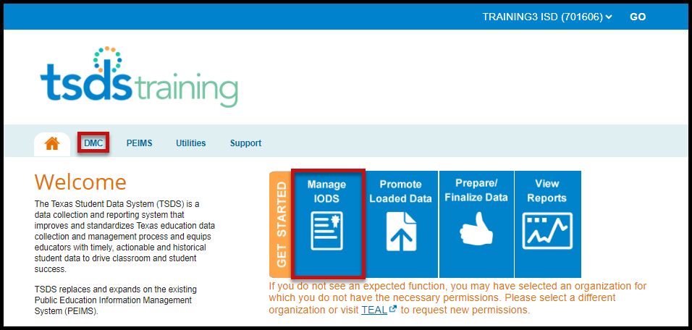

- On the Data Management Center (DMC) screen select Monitor Validations > Schedule L2 Validation Jobs.

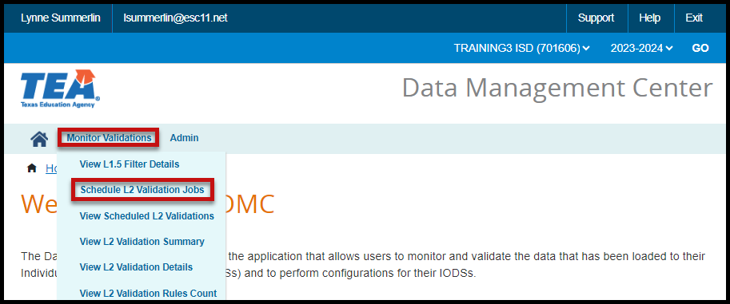

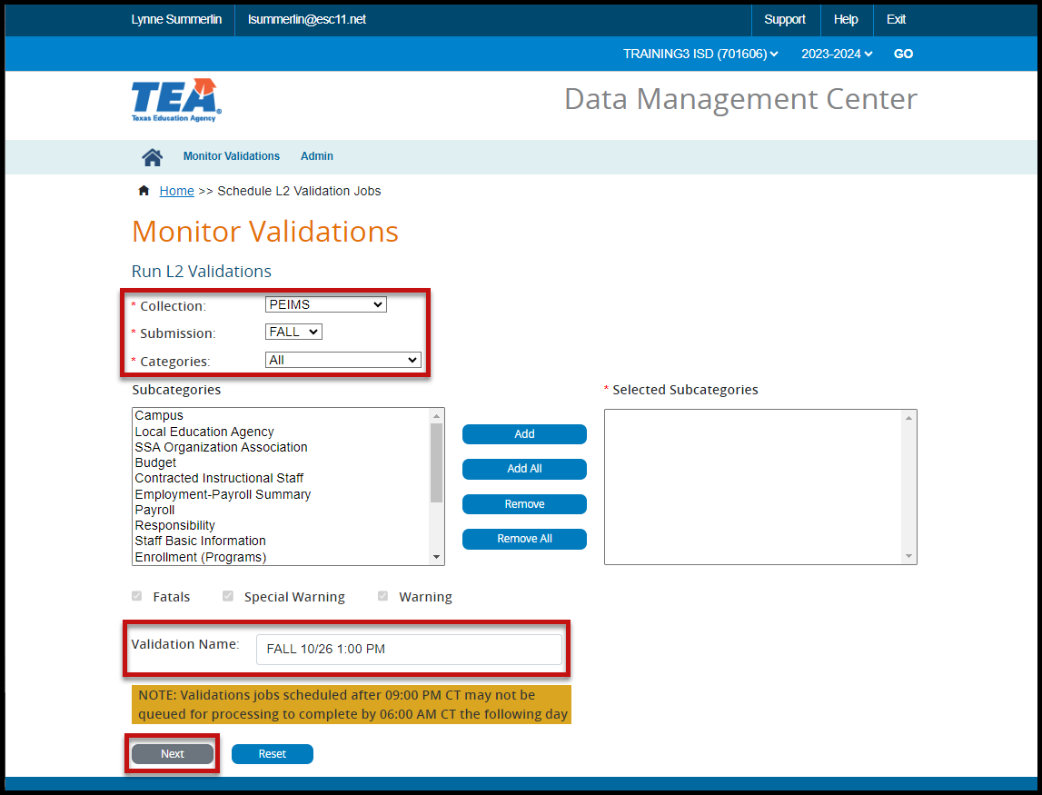
- The Monitor Validations Run L2 Validations screen appears. This screen is very similar to the Monitor Validations screen in TSDS.

- Make the appropriate selections from the pull-down menus for Collection, Submission, and Categories.
- Enter a Validation Name.
- Click Next. The Monitor Validations View L2 Validation Requests Summary screen appears.
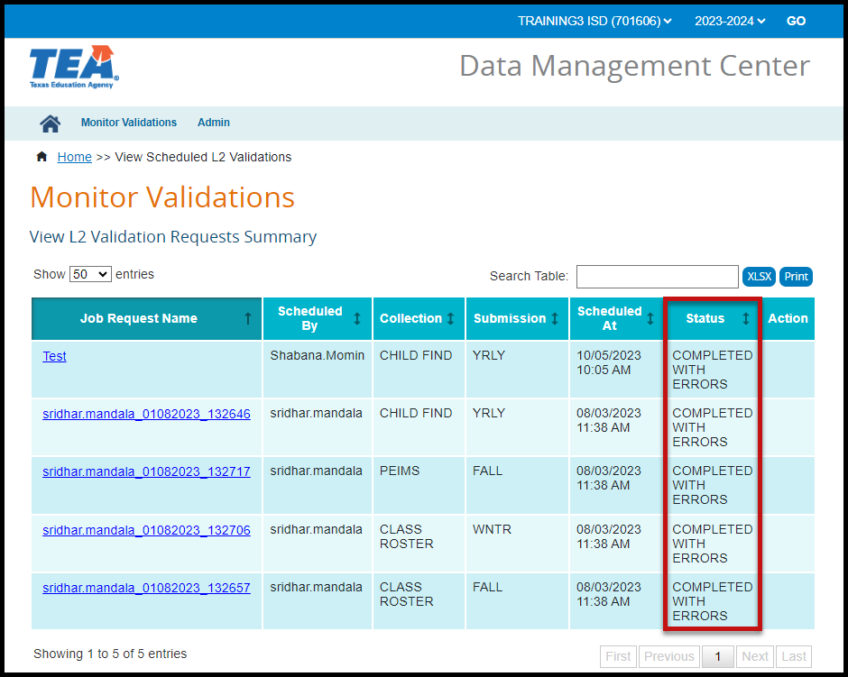

Note: Validation jobs scheduled after 9:00 PM CT may not be queued for processing to complete by 6:00 AM CT the following day.

- After the Validation job has been completed, errors can be viewed by Summary, Details, or Rules Count.

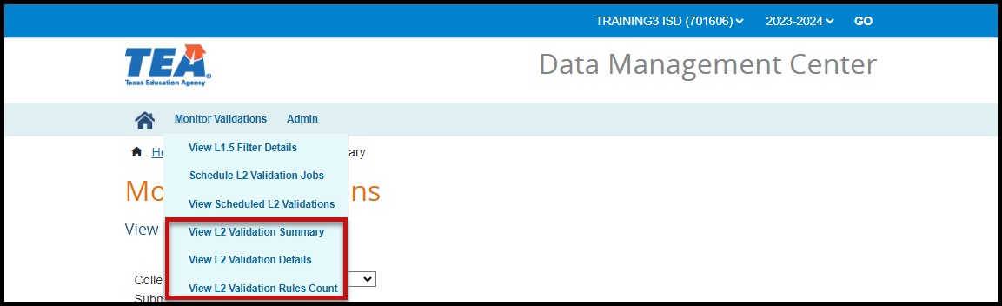
L2 Validation Summary: User can view errors by specific Category for a specific Collection and Submission. Data on screen can be sorted by clicking/double clicking on the column headers. Data can be searched using the Search Table. Data can also be Printed or saved in XLSX format.

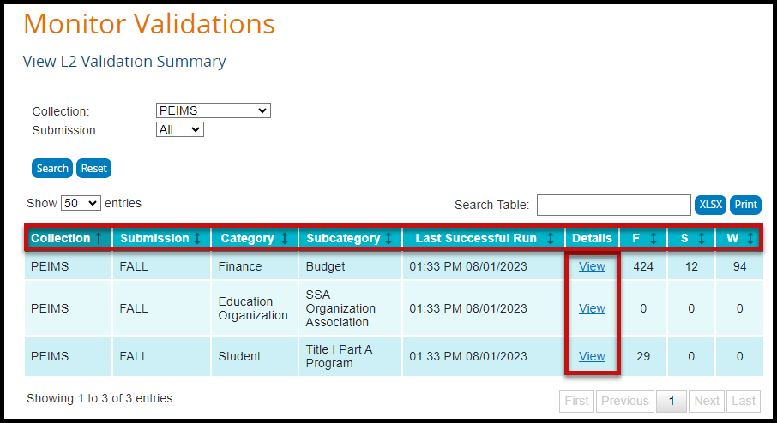

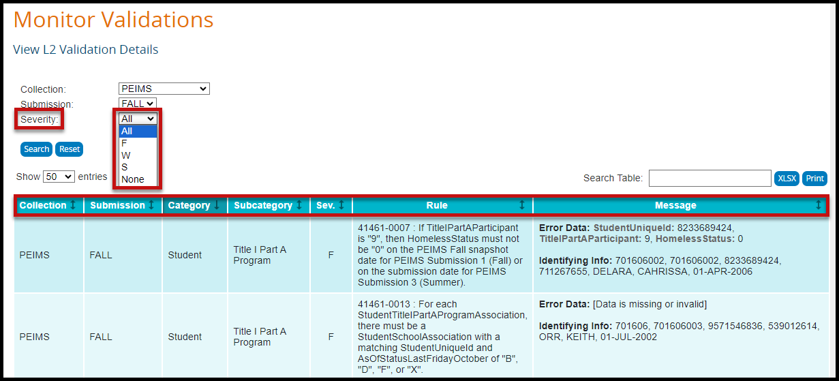
L2 Validation Details: User can view errors by Severity for a specific Collection and Submission. Data on screen can be sorted by clicking/double clicking on the column headers. Data can be searched using the Search Table. Data can also be Printed or saved in XLSX format.

Count L2 Validation Rules: User can view the Number of Fatals, Special Warnings, and Warnings for a specific Collection and Submission by Rule Number (no specific Identifying Info included). Data on screen can be sorted by clicking/double clicking on the column headers. Data can be searched using the Search Table. Data can also be Printed or saved in XLSX format.
